**Supporting Information**

**A Low-****Permeability and Flexible Polymer Tube for**

**Long-Life Fiber Lithium-Ion Batteries**

*Haibo Jiang+, Xiaocheng Gong+, Jiaqi Wang, Zhe Yang, Chuanfa Li, Yao Long, Chenhao Lu, Shiqi Sun, Kun Zhang, Yingfan Chang, Pengzhou Li, Xiangran Cheng, Huisheng Peng, Bingjie Wang\**

*H Jiang, X Gong, J Wang, Z Yang, C Li, Y Long, C Lu, S Sun, K Zhang, Y Chang, P Li, X Cheng, Prof. H Peng, Prof. B Wang*

*State Key Laboratory of Molecular Engineering of Polymers, Department of Macromolecular Science, Institute of Fiber Materials and Devices, and Laboratory of Advanced Materials, Fudan University, Shanghai, 200438, China.*

*E-mail:* *wangbingjie@fudan.edu.cn*

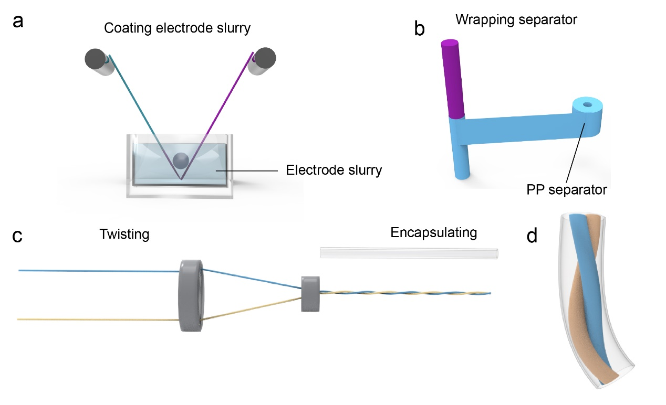

**Figure S1.** The production process of FLIBs. (**a**) Coating of fiber current collectors. (**b**) Wrapping of negative fibers with 3-mm-width separator strips. (**c**) Twisting of positive and negative fibers using a home-made winch machine. (**d**) Encapsulation of FLIBs with polymer tubes.

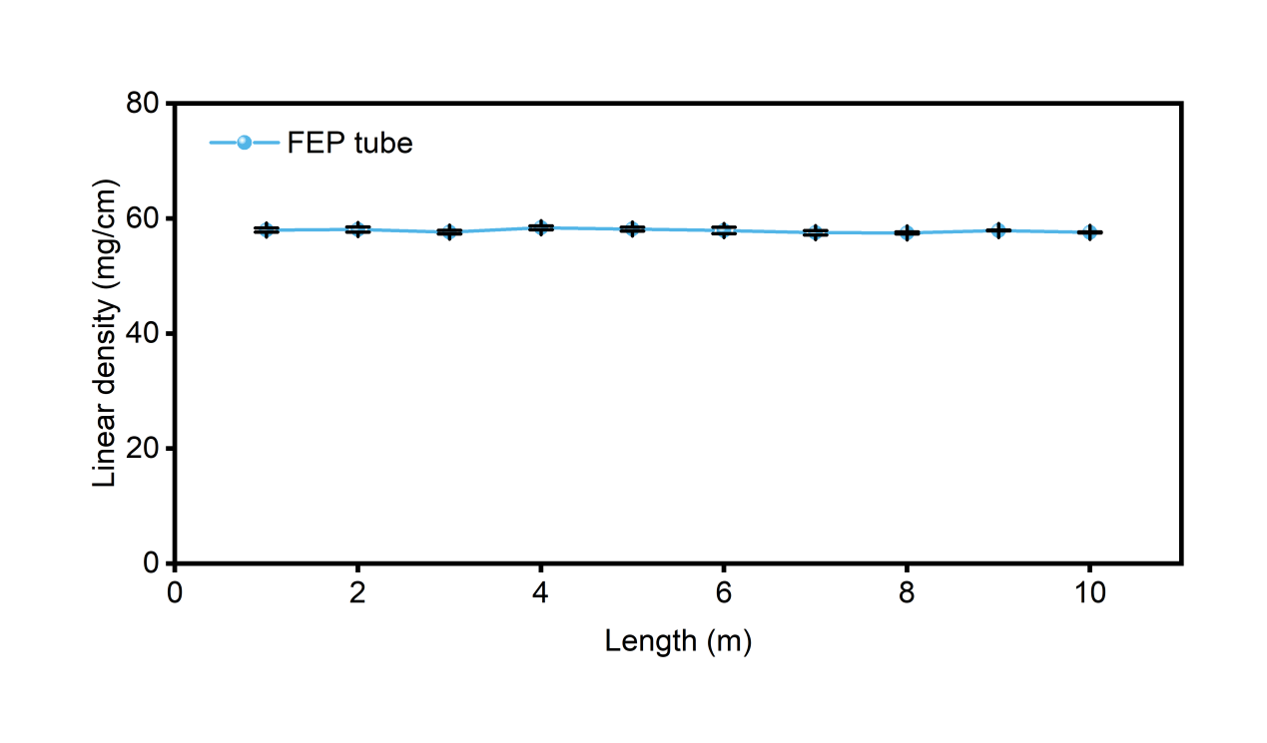

**Figure S2.** Linear density of FEP tubes.

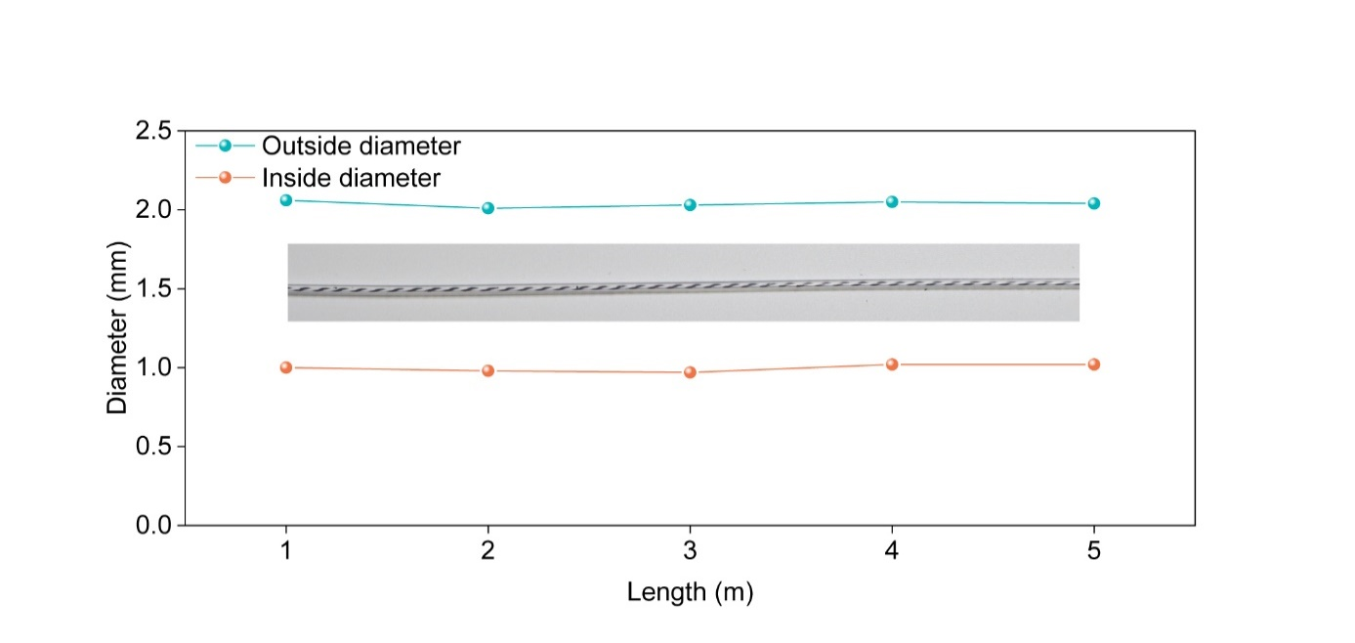

**Figure S3.** The inner and outer diameters of the FEP tubes.

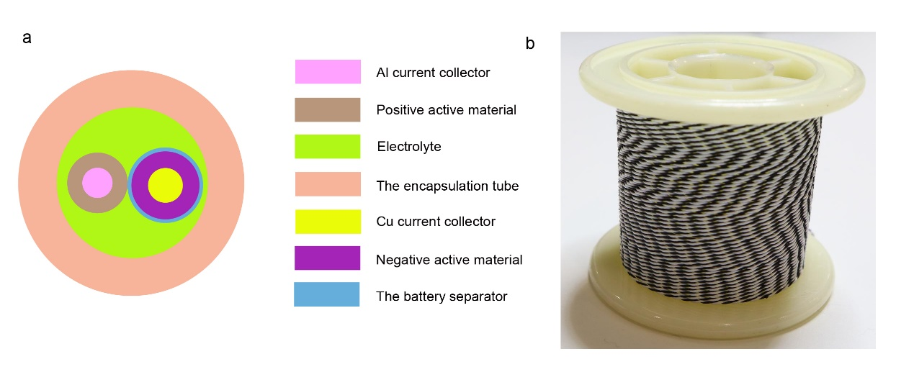

**Figure S4.** (**a**) The cross-section schematic diagram and (**b**)photograph of FLIBs.

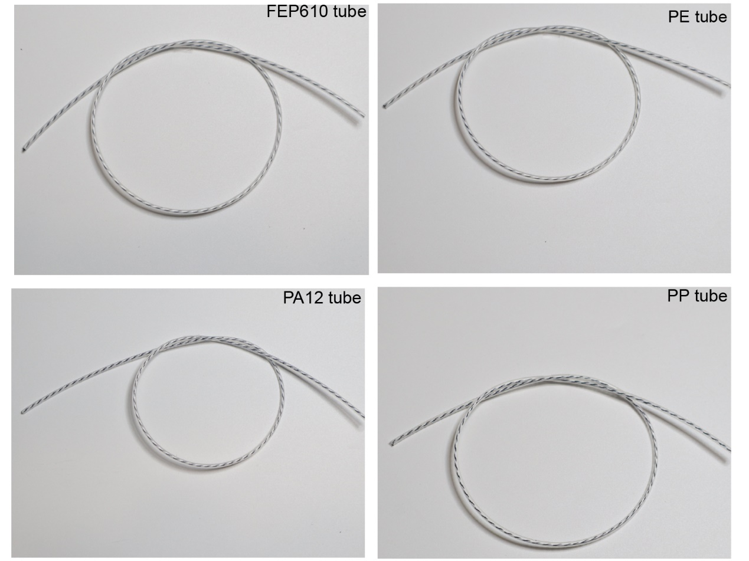

**Figure S5.** Photograph of the four tubes, exhibiting transparency and flexibility.

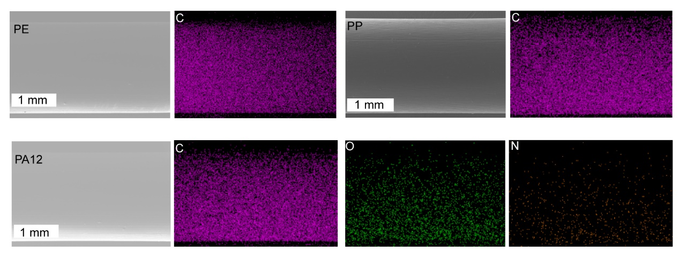

**Figure S6.** EDS mapping of three tubes: PE (C element), PP (C element), PA12 (C, O, and N elements).

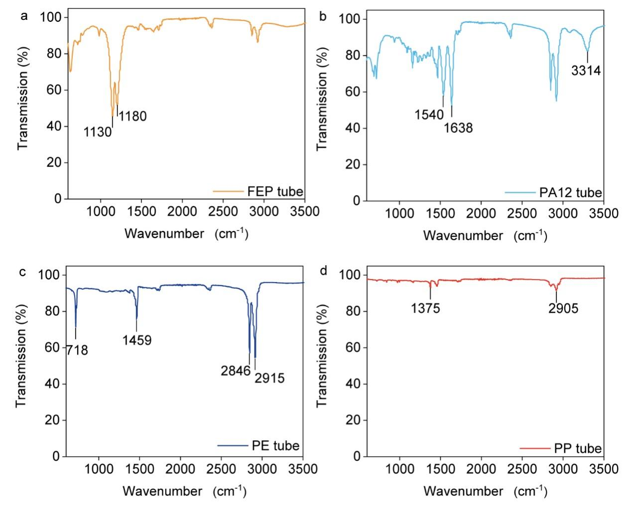

**Figure S7.** FTIR spectra of (**a**)FEP tube, (**b**)PA12 tube, (**c**) PE tube, and (**d**)PP tube, respectively, in the range of 500-3500 cm-1.

As illustrated schematically in Figure S7, for the PP tube, the C-H bending vibration peak was observed at 1375 cm-1, and the C-H stretching vibration peak was observed at 2905 cm-1. For the PE tube, the characteristic peaks mainly included the C-H stretching vibration peak of CH2 (2915 cm-1 and 2846 cm-1), the bending vibration peak of C-H (1459 cm-1), and the swaying vibration peak of C-H (718 cm-1). For the PA12 tube, the peaks at 3314 cm-1 and 1638 cm-1 represented the stretching vibration absorption of N-H and C=O, and the N-H bending vibration absorption peak appeared at 1540 cm-1.

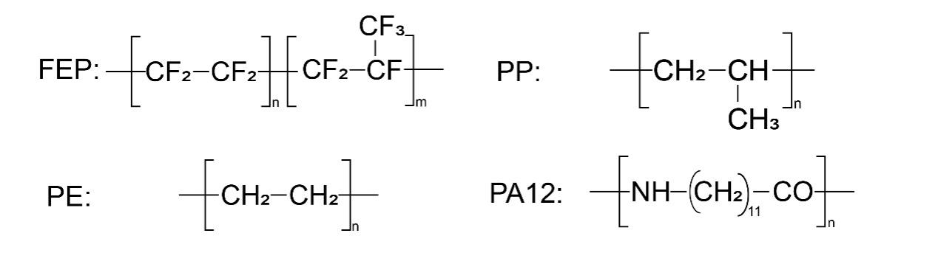

**Figure S8.** Structural formulas of FEP, PP, PE and PA12, respectively.

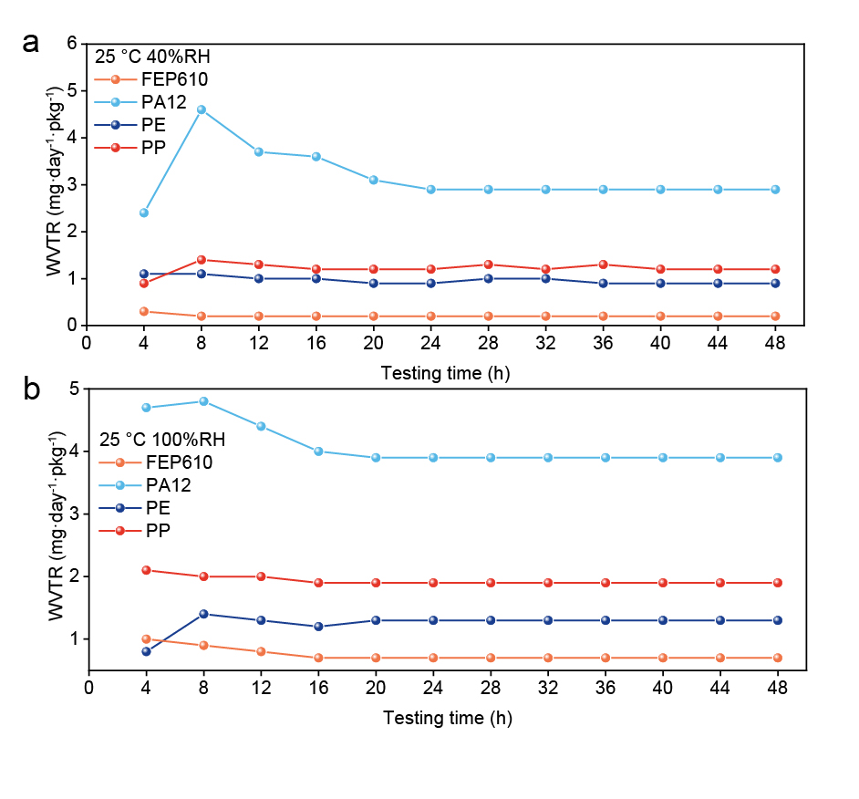

**Figure S9.** Water vapor transmission rates (WVTR) of four tubes at (**a**) 40% RH and (**b**) 100% RH. The FEP610 tube exhibited the lowest water vapor permeability under varying humidity conditions.

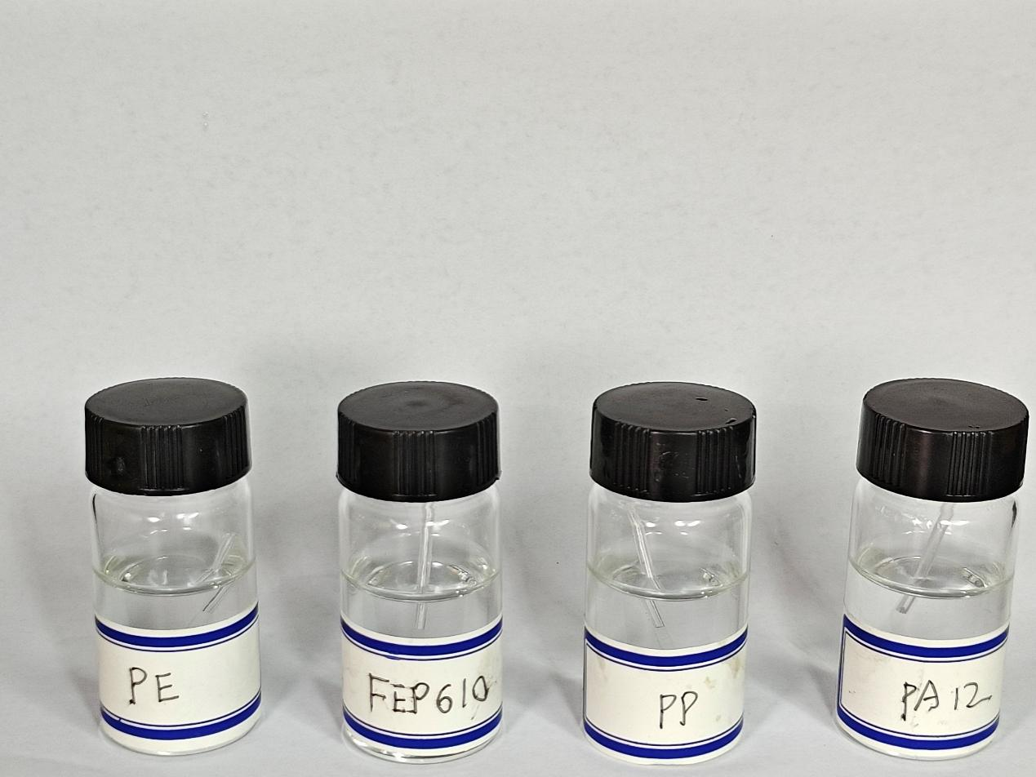

**Figure S10.** The four tubes were immersed in an electrolyte solution (1 M LiPF6 in a 1:1 mixture of EC and DMC) for ten days without any observable change in color.

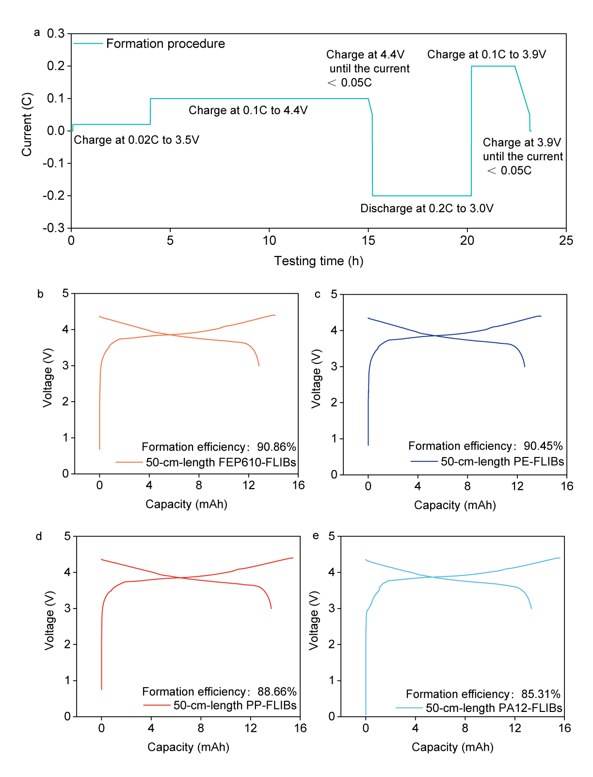

**Figure S11.** Formation of FLIBs. (**a**) Formation procedure of FLIBs. Formation curves of (**b**)FEP610-FLIBs, (**c**)PE-FLIBs, (**d**)PP-FLIBs, and (**e**)PA12-FLIBs, respectively.

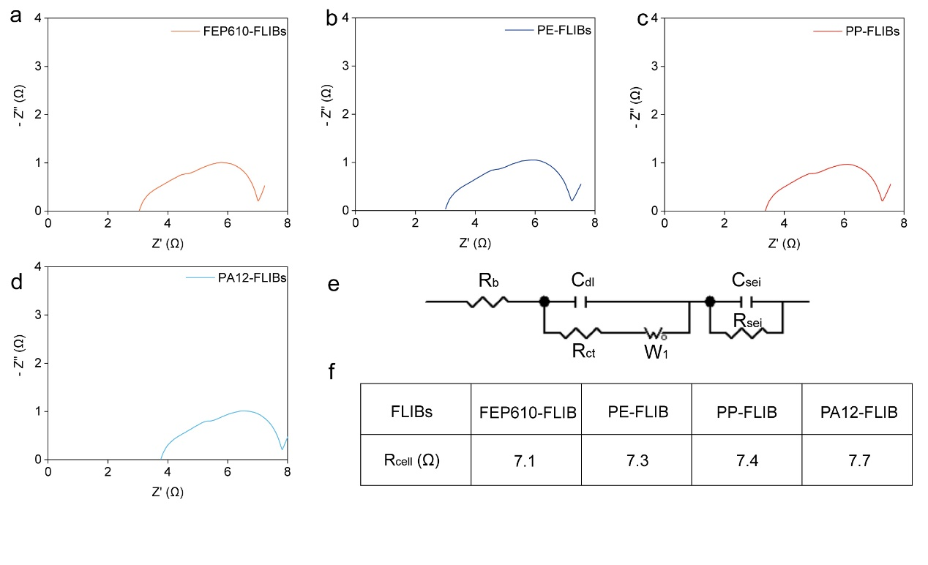

**Figure S12.** Nyquist plots of (**a**)FEP610-FLIBs, (**b**)PE-FLIBs, (**c**) PP-FLIBs, and (**d**)PA12-FLIBs after the formation procedure. (**e**) Equivalent circuit model comprising Rb (Ohmic resistance of the electrolyte), Rsei (SEI resistance), Csei (SEI capacitance), Rct (Charge transfer resistance), Cdl (Double layer capacitance), and W1 (Warburg impedance). (**f**) Corresponding fitting results of Rcell.

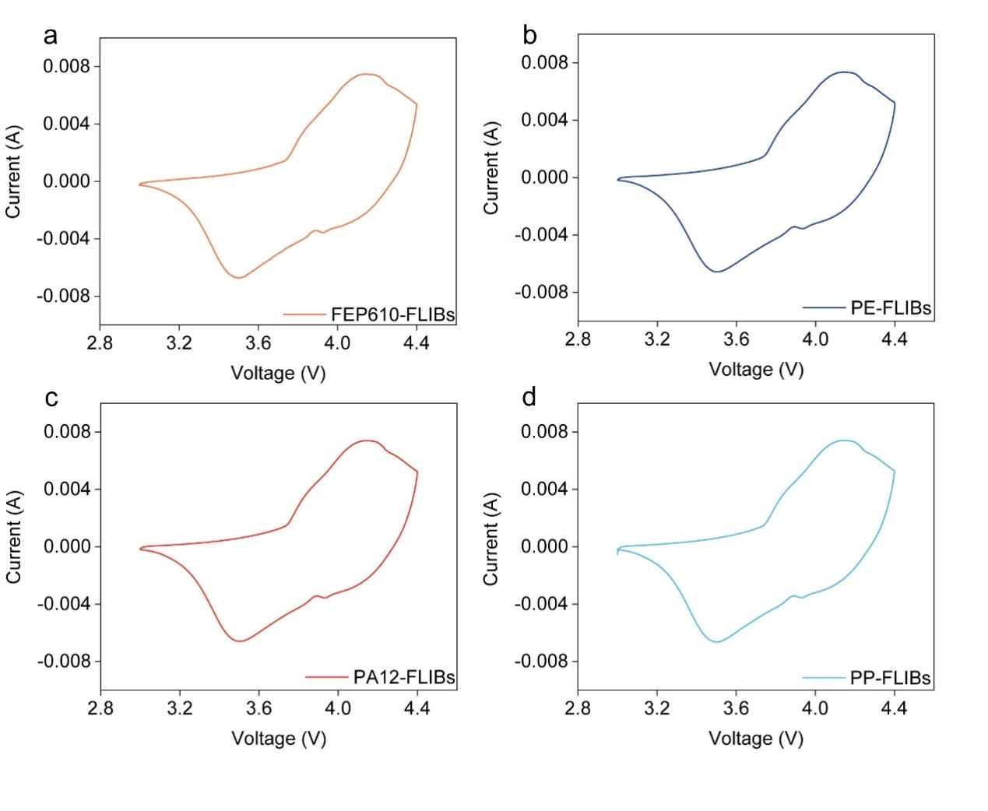

**Figure S13.** CV curves of (**a**) FEP610-FLIBs, (**b**)PE-FLIBs, (**c**)PA12-FLIBs, and (**d**) PP-FLIBs. The scan rate was 0.3 mV/s. The four curves exhibited nearly identical behavior, suggesting that the variation in packaging materials does not introduce adverse effects to FLIBs.

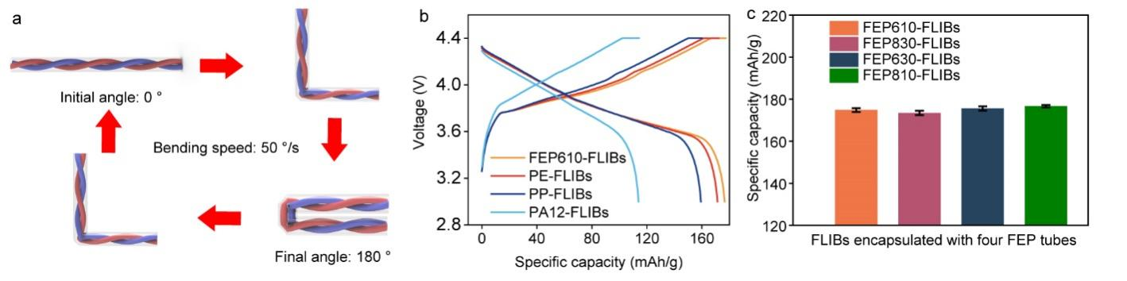

**Figure S14.** Bending performance of FLIBs. (**a**)Procedure for the bending test. (**b**)Corresponding charge-discharge profiles of four FLIBs at the 10,000th bending cycle. (**c**)Specific capacity of four FEP-FLIBs after 10,000 bending cycles.

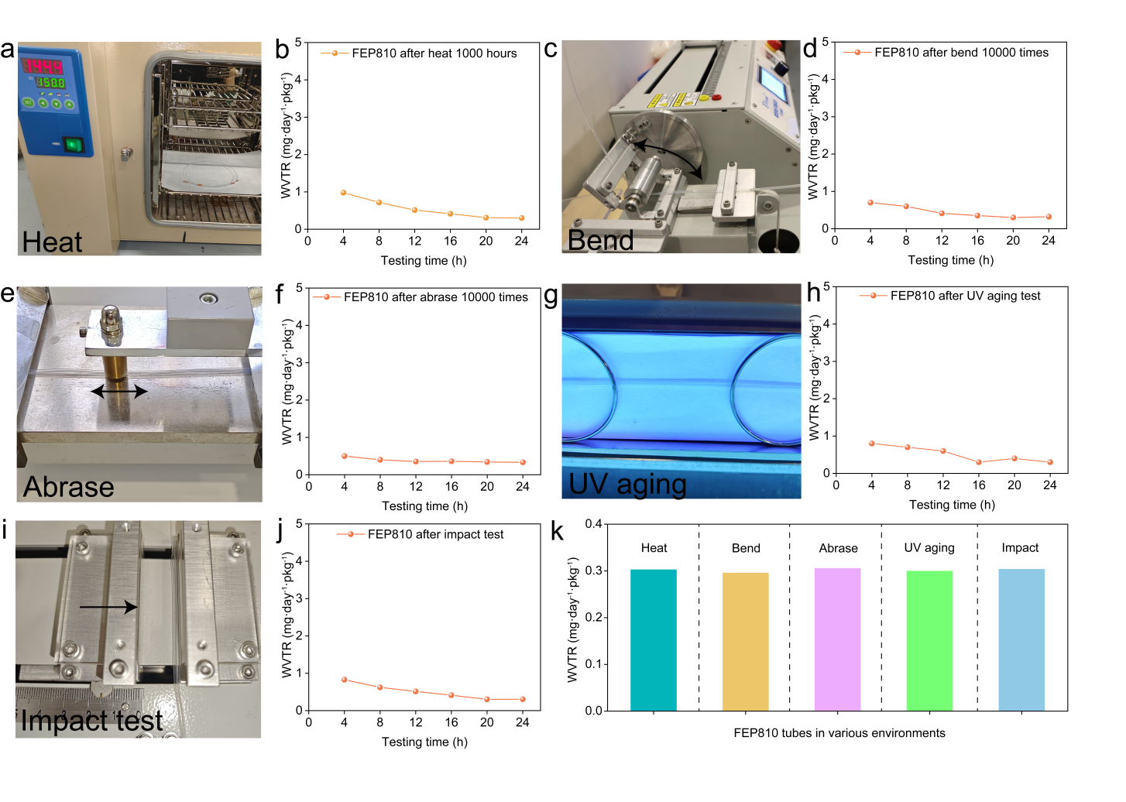

**new Figure S15.** Images depict FEP810 tubes under the conditions of (**a**) heating, (**c**) bending, (**e**) abrasing, (**g**) UV aging, and (**i**) impact tests, respectively. WVTR of FEP810 tubes after (**b**) heating,(**d**) bending, (**f**) abrasing, (**h**) UV aging, and (**j**) impact tests. (**k**) The WVTR values of FEP810 tubes remained almost unchanged in various environments.

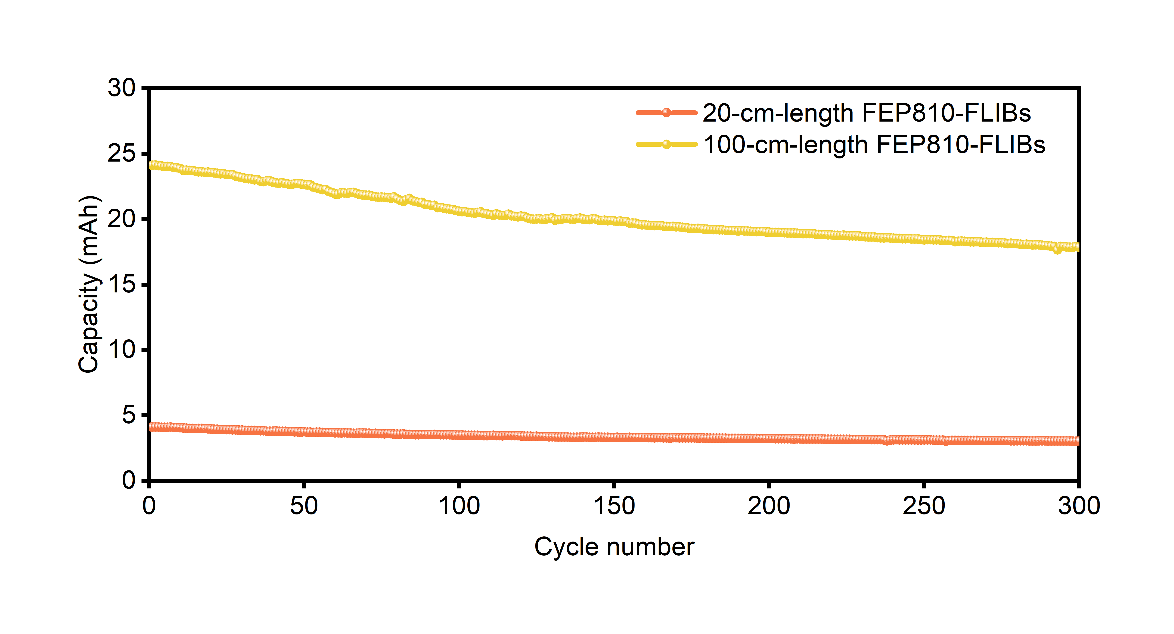

**Figure S16.** Cycling performance of FEP810-FLIBs (20 cm and 100 cm).

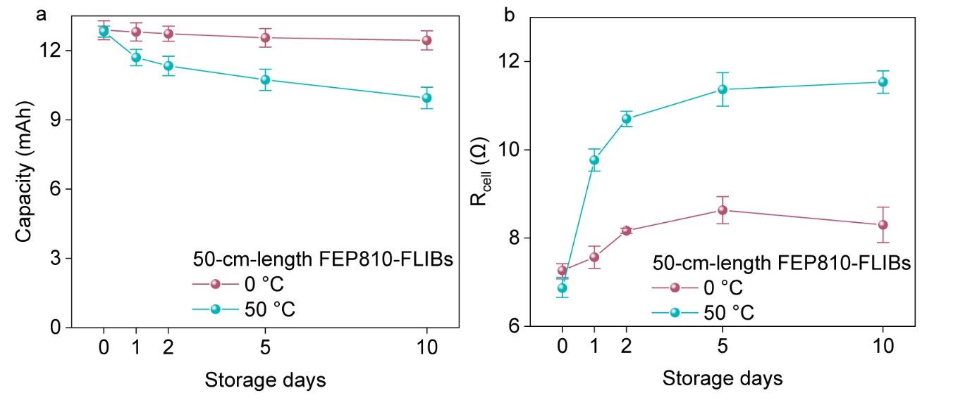

**Figure S17.** (**a**) Capacityand (**b**)Internal resistance variationof 50-cm-length FEP810-FLIBs vs. storage days at 0 °C and 50 °C, respectively.

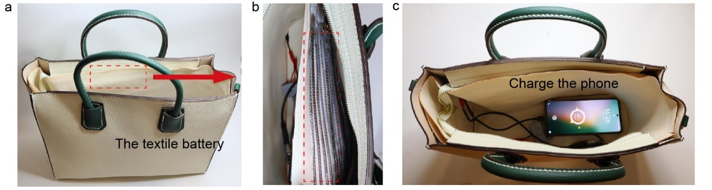

**Figure S18.** A handbag crafted from FEP810-FLIBs designed to enable phone charging anytime, anywhere.

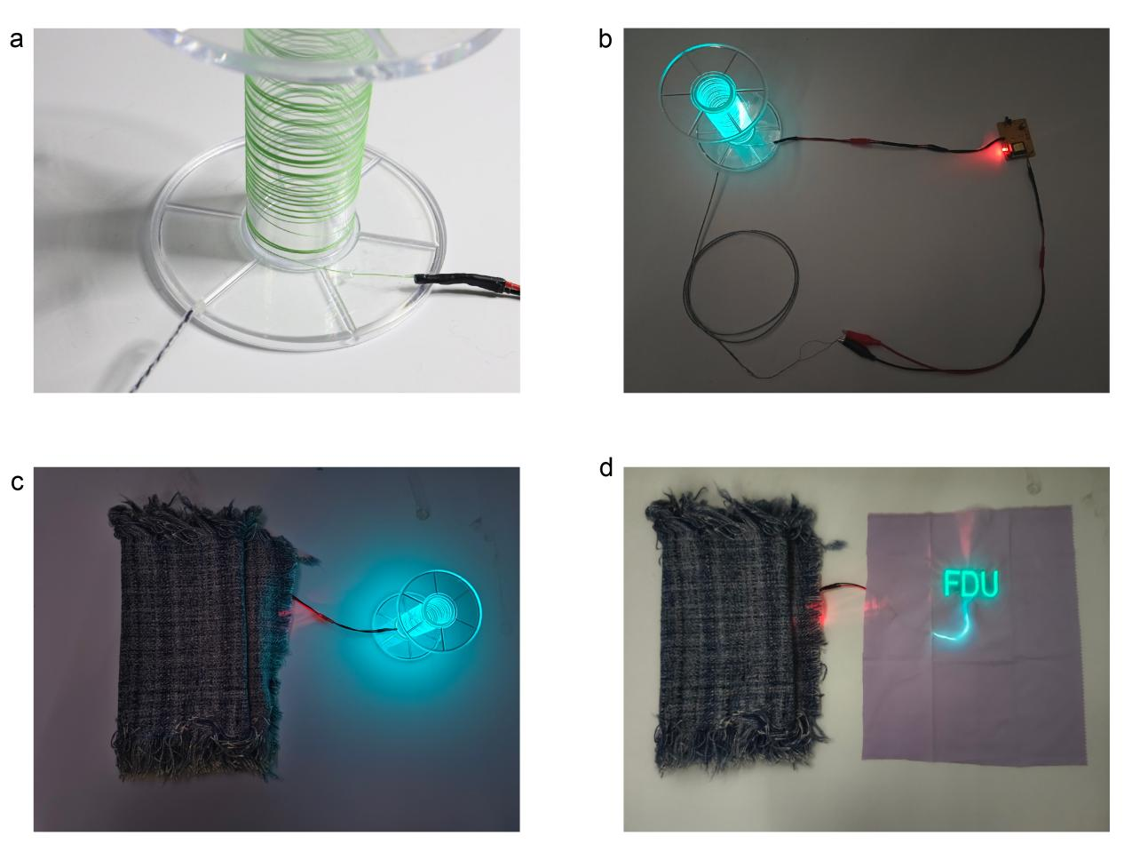

**Figure S19.** The battery textile provides power to the light-emitting fiber. (**a**) Photograph of the light-emitting fiber. (**b**) A 100-cm-length FEP810-FLIBs can light up the light-emitting fiber. (**c**)The battery textile supplies power to light-emitting fiber. (**d**) The battery textile supplies power to the light-emitting fabric.

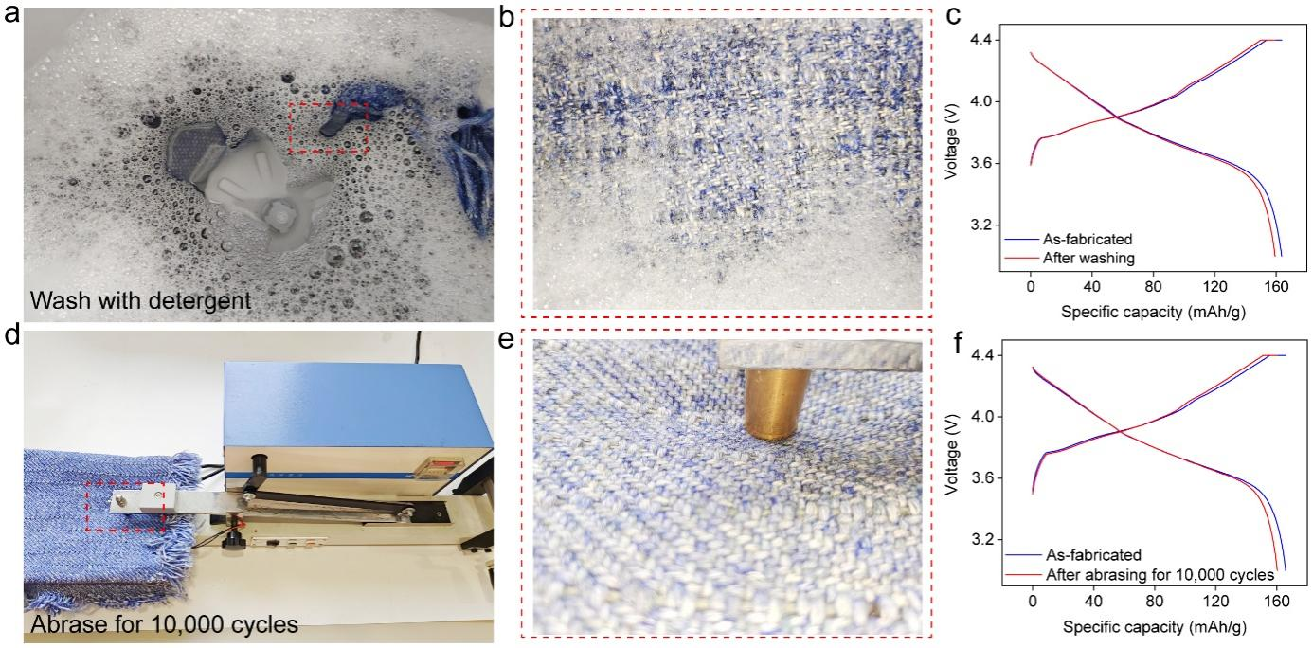

**new Figure S20. Washing and abrasing resistances of FEP810-FLIBs textiles.** (**a**) Photograph of FEP810-FLIBs textile under washing with detergent. (**b**) enlarged image of (a). (**c**) Charging-discharging profiles of FEP810-FLIBs textile before and after washing. (**d**) Photograph of FEP810-FLIBs textile under abrasing. (**e**) enlarged image of (d). (**f**) Charging-discharging profiles of FEP810-FLIBs textile before and after abrasing for 10,000 cycles.